Visvesvaraya Technological University
Jnana Sangama, Belagavi-590018
Department of Computer Science and Engineering

2024-2025

A project Design
On
“Blockchain-based File Sharing System”
Submitted
By
Nilesh Satpute
USN: 2VX23MC097

System Design:
On submitting valid data
After clicking on login button
Insert Registration details into database
User Login
Admin login
Login Page
(Id and password)
My Profile
Files
View Users
Change Password
If not registered
View Feedback
Fill Registration details
Homepage

View Files

Shared Files
View Logs
Logs

Feedback

Logout

Use Case Diagram:
User:
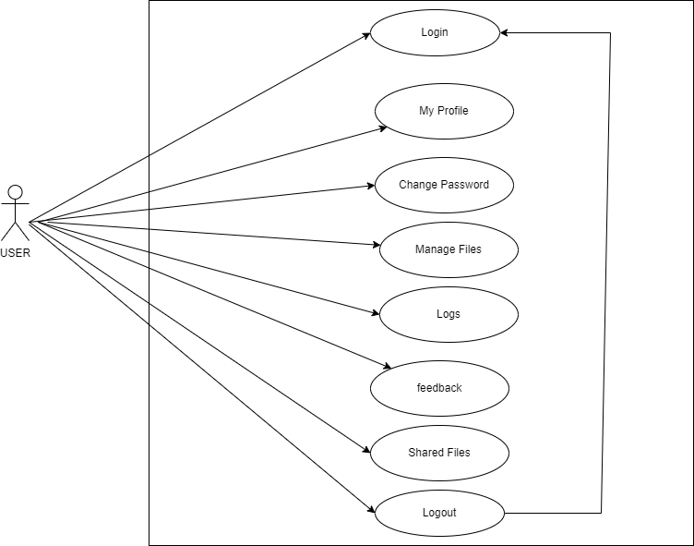

Admin:

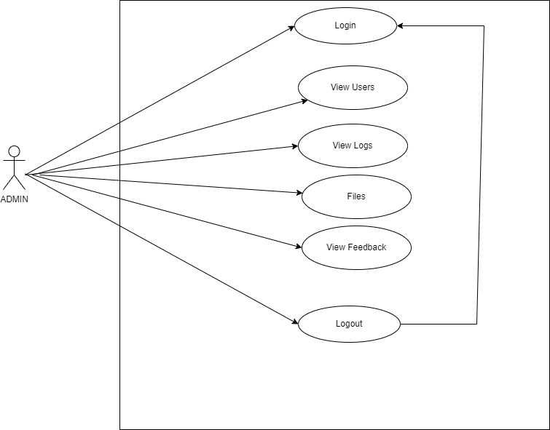

Sequence Diagram:
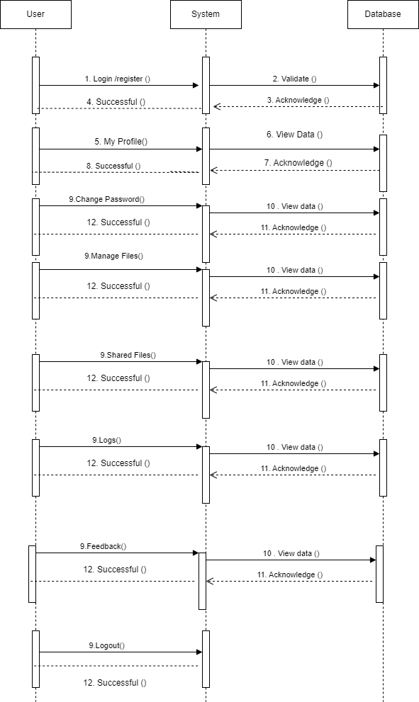
E-R Diagram
